**4.28. Class tasks and assignments**

这部分内容是给今天上课了的同学完成。如果你今天没有来上课，请看下两页的安排。

Group in-class writing (小组课堂讨论活动，每个小组提交一份就好，今天中午12点前完成交给课代表，然后课代表统一交给叶老师。请利用好课堂时间有效率地和组员一起完成。)

|  |
| --- |
| Your group number _______ (你们小组的号码) |
| Who participated in today’s discussion: （今天参与了讨论的同学名字和他们的字母代号ABCD…） |
| Who is submitting this group form today: Member B  今天负责提交作业的小组代表___________ |
| |  | | --- | | **Final Project**  **Step 1: Describe your field and a topic (Member B)** | | * What does 物联网mean? What do you study in this major? (Describe) * Why is this major important? * Why is this major interesting? * Why is this major connected with the world? * How is this major connected with Chinese culture and other cultures in the world? * At least 250 words * Due by noon today   Write here:  Word count | |

**Assignment for next class:**

* **Announcement:** no class next Wednesday 5/4. See you on Thursday 5/5.
* Read Chapter 22 before next class. (Thursday 5/5)
* Finish your **weekly reflective report**. (At least 250 words). Due **Sunday night 11:59 pm**.
  + Reflect on your major (The Internet of Things物联网) and your personal goals (career, study). What is the connection between your major, your career goals and the world?
  + How does The Internet of Things物联网 relate to everyone’s life?
  + Does learning English help you achieve your goals in study and in your future career? Please explain.
  + Does learning about other cultures help you achieve your goals in study and in your future career? Please explain.
  + Read the rubric closely and include the rubric in your paper

|  |  |  |
| --- | --- | --- |
| **Rubric: Weekly Journal Report (updated on April 5th, 2022)** | | |
| **Point** | **Rationale** | **Suggestions** |
| 5 | * Respond to **all** of the questions and prompts with **great details** * Little to no grammar/spelling mistakes * Author’s genuine work * Follow all of the format instructions correctly (write down the author’s name, include this rubric, at least 250 words, list the word count, paragraphs and topic sentences) | No suggestions. Continue with your good work. |
| 4 | * Respond to **some or all** of the questions and prompts with **some details** *or* * **Some** grammar/spelling mistakes *or* * Follow all of the format instructions correctly (write down the author’s name, include this rubric, at least 250 words, list the word count, paragraphs and topic sentences) | Read your essay again and consider how to add more details, correct grammar mistakes. |
| 3 | * Respond to **some or all** of the questions and prompts with **some details** *or* * **Some** grammar/spelling mistakes *or* * Did not meet some format requirements, missing the author’s name, or this rubric, or the word count or paragraphs and topic sentences | Read your essay again and consider how to add more details, correct grammar mistakes. Remember to follow the instructions. |
| 2 | * Respond to **some** of the questions and prompts with **little details** *or* * **Many** grammar/spelling mistakes (incomprehensible) * Not the author’s genuine work (work is mostly plagiarized or translated online) * Did not meet some format requirements, missing the author’s name, or this rubric, or the word count or paragraphs and topic sentences | Rewrite your essay.  Do not plagiarize work again. |
| 1-0 | * The author did minimal work, *or* * The work was totally plagiarized or the work was from online translation (the work does not reflect the author’s proficiency or voice) * Did not follow the format requirements. | Rewrite your essay. |

Important note: 因为时间冲突没有上课的同学，请完成以下内容。

**因为这个是期末考试项目，所以你们也是按照小组完成。如果你不了解如何完成小组作业，可以问课代表。**

**期末项目小组分组**

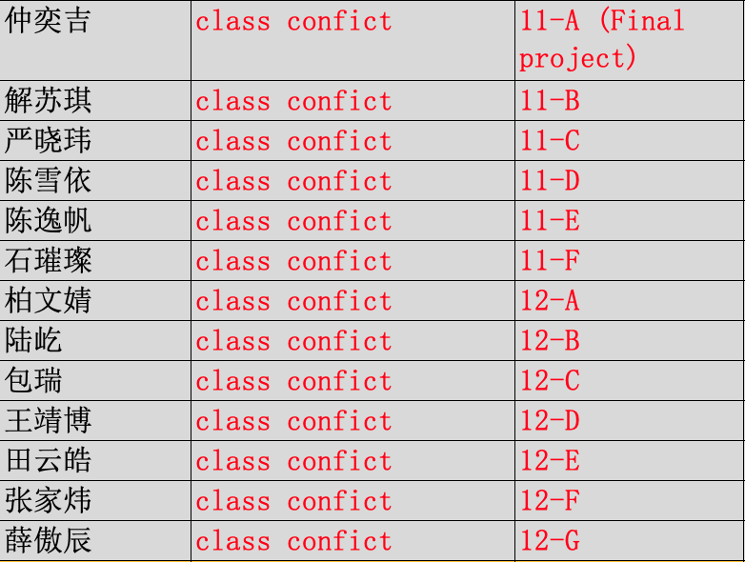

You need to submit the form to the Course Representative by **Sunday night 11:59pm**. (Don’t forget, you also need to finish weekly reflective report, that is also due Sunday night. That means, you need to submit **multiple things** to the Course Representative by Sunday night.)

|  |
| --- |
| Your group number _______ (你们小组的号码) |
| Who participated in today’s discussion: （今天参与了讨论的同学名字和他们的字母代号ABCD…） |
| Who is submitting this group form today: Member B  今天负责提交作业的小组代表名字___________  **Watch today’s recorded class, and answer the following questions:**   1. Did your team members watch the recorded class? 2. In this week’s lecture, I introduced two strategies of writing an argumentation essay. What are these two strategies? |
| |  | | --- | | **Final Project**  **Step 1: Describe your field and a topic (Member B)** | | * What does 物联网mean? What do you study in this major? (Describe) * Why is this major important? * Why is this major interesting? * Why is this major connected with the world? * How is this major connected with Chinese culture and other cultures in the world? * At least 250 words   Write here:  Word count: | |

**Assignment for next class:**

* **Announcement:** no class next Wednesday 5/4. See you on Thursday 5/5.
* Read Chapter 22 before next class. (Thursday 5/5)
* Finish your **weekly reflective report**. (At least 250 words). Due **Sunday night 11:59 pm**.
  + Reflect on your major (The Internet of Things物联网) and your personal goals (career, study). What is the connection between your major, your career goals and the world?
  + How does The Internet of Things物联网 relate to everyone’s life?
  + Does learning English help you achieve your goals in study and in your future career? Please explain.
  + Does learning about other cultures help you achieve your goals in study and in your future career? Please explain.
  + Read the rubric closely and include the rubric in your paper

|  |  |  |
| --- | --- | --- |
| **Rubric: Weekly Journal Report (updated on April 5th, 2022)** | | |
| **Point** | **Rationale** | **Suggestions** |
| 5 | * Respond to **all** of the questions and prompts with **great details** * Little to no grammar/spelling mistakes * Author’s genuine work * Follow all of the format instructions correctly (write down the author’s name, include this rubric, at least 250 words, list the word count, paragraphs and topic sentences) | No suggestions. Continue with your good work. |
| 4 | * Respond to **some or all** of the questions and prompts with **some details** *or* * **Some** grammar/spelling mistakes *or* * Follow all of the format instructions correctly (write down the author’s name, include this rubric, at least 250 words, list the word count, paragraphs and topic sentences) | Read your essay again and consider how to add more details, correct grammar mistakes. |
| 3 | * Respond to **some or all** of the questions and prompts with **some details** *or* * **Some** grammar/spelling mistakes *or* * Did not meet some format requirements, missing the author’s name, or this rubric, or the word count or paragraphs and topic sentences | Read your essay again and consider how to add more details, correct grammar mistakes. Remember to follow the instructions. |
| 2 | * Respond to **some** of the questions and prompts with **little details** *or* * **Many** grammar/spelling mistakes (incomprehensible) * Not the author’s genuine work (work is mostly plagiarized or translated online) * Did not meet some format requirements, missing the author’s name, or this rubric, or the word count or paragraphs and topic sentences | Rewrite your essay.  Do not plagiarize work again. |
| 1-0 | * The author did minimal work, *or* * The work was totally plagiarized or the work was from online translation (the work does not reflect the author’s proficiency or voice) * Did not follow the format requirements. | Rewrite your essay. |